1. Create a repository in your GitHub

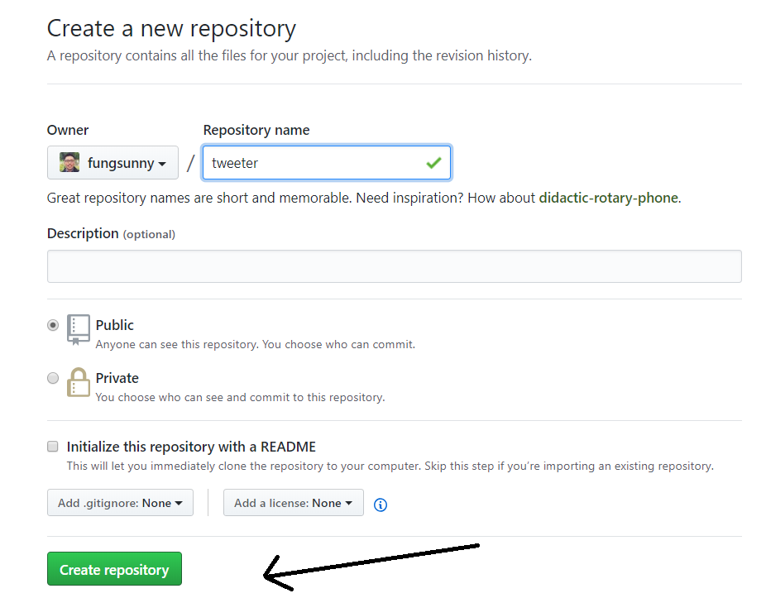

1. Create a Procfile file using text editor. In this is case, my Procfile contains information includes:
   1. My code, which is a python file is called “PlotBot6.py”
   2. The program that runs my code is “python”.
   3. The command I want Heroku to see is “worker:”

This Procfile does not have an extension. The key is to have it name exactly “Procfile”.

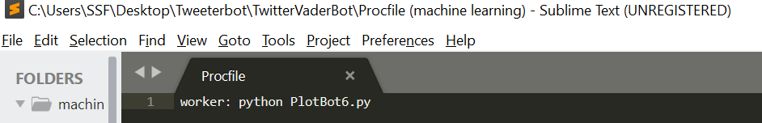

1. Create Requirements.txt, it has to be saved as exactly as “Requirements.txt”. You can make this using a text editor as well, but make sure the extension is .txt.

Inside the text file, you need to add all the libraries you used for your code and their corresponding versions. This tells Heroku what modules it needs to run your app.

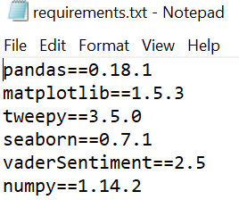

Don’t know what libraries and their versions your code is running?

In the same environment you built your code on, run a command line command called “pip freeze”. It will list all the libraries and their corresponding versions.

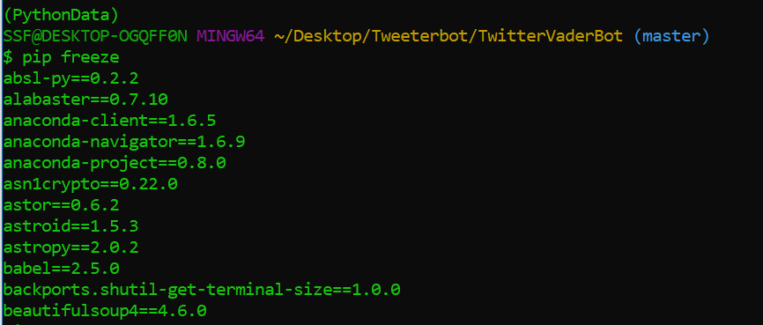

1. Push your code to Github. Include both the Procfile and requirements.txt files in the directory.
2. Go to heroku.com and create an account.
3. Create an APP on Heroku

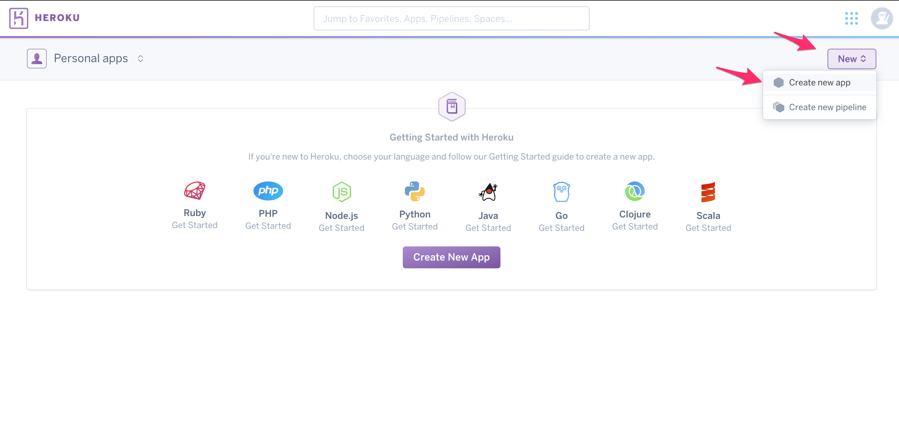

1. App name

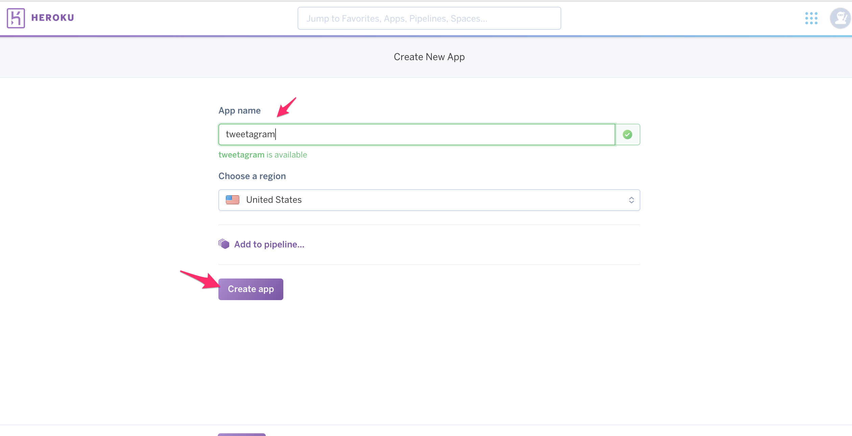

1. Connect to your git repo

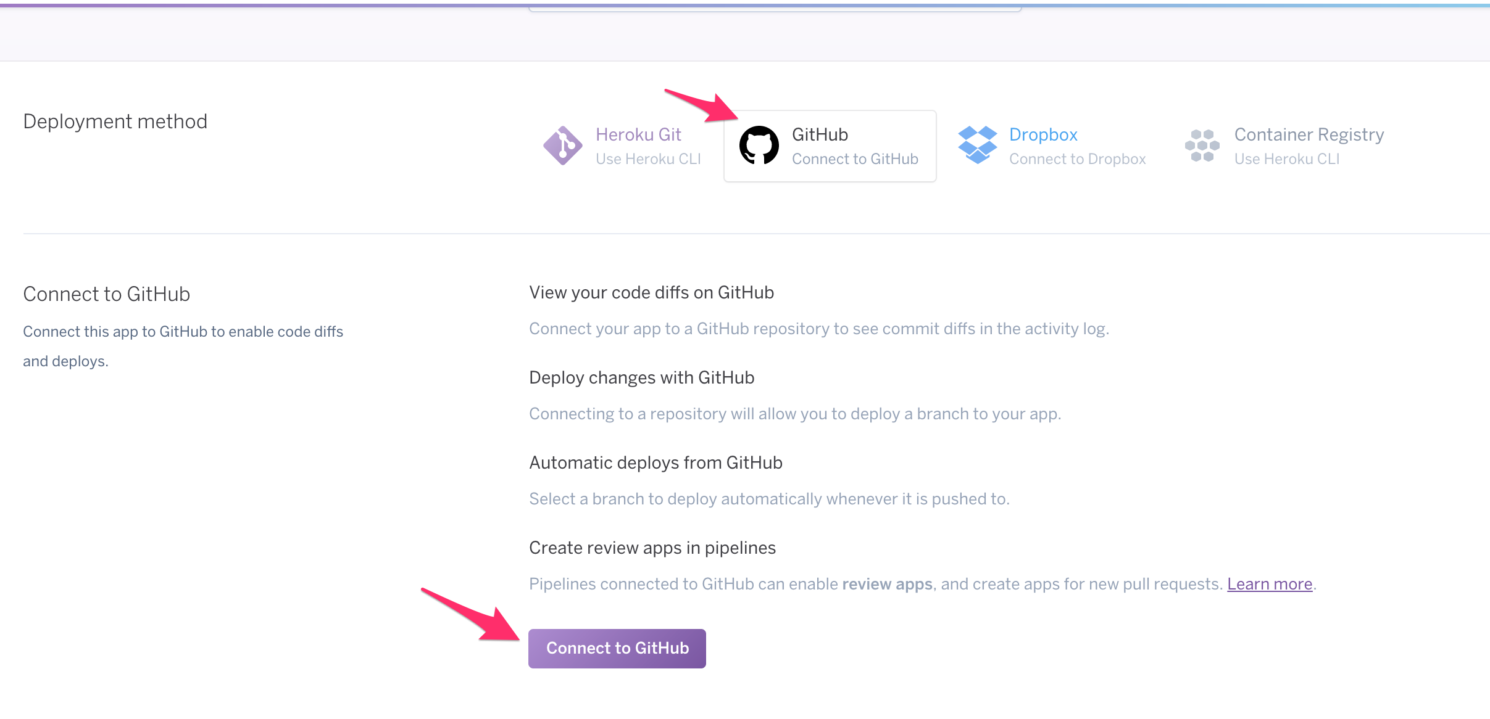

1. Link your GitHub repo using the name of the repository you created

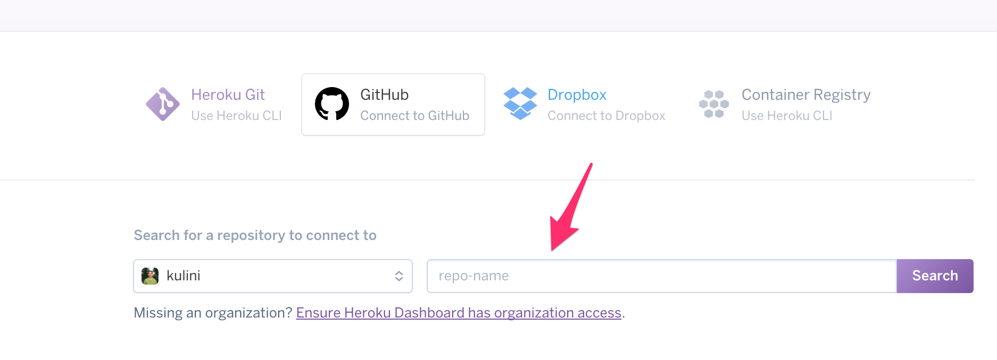

1. Search for your repo’s name on Github and **connect** the repo to Heroku

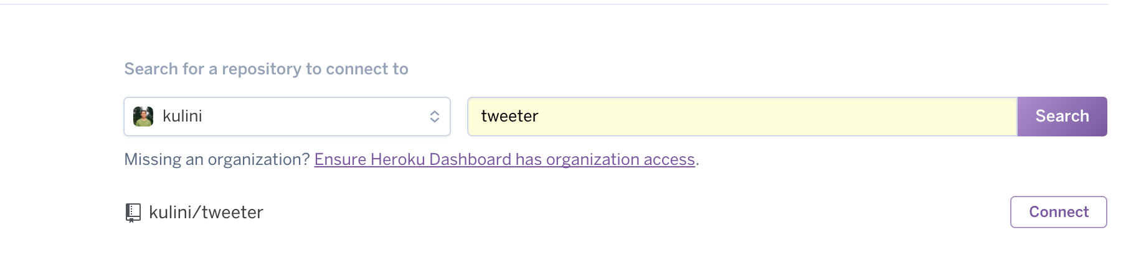

1. Click on Enable Automatic Deploys, which will allow the Heroku server to restart your app whenever you push a change to your Github repo.

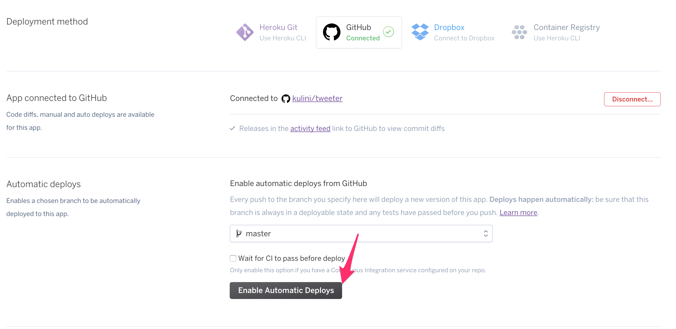

1. Click on the Resources tab, followed by clicking the edit button with the pencil icon.

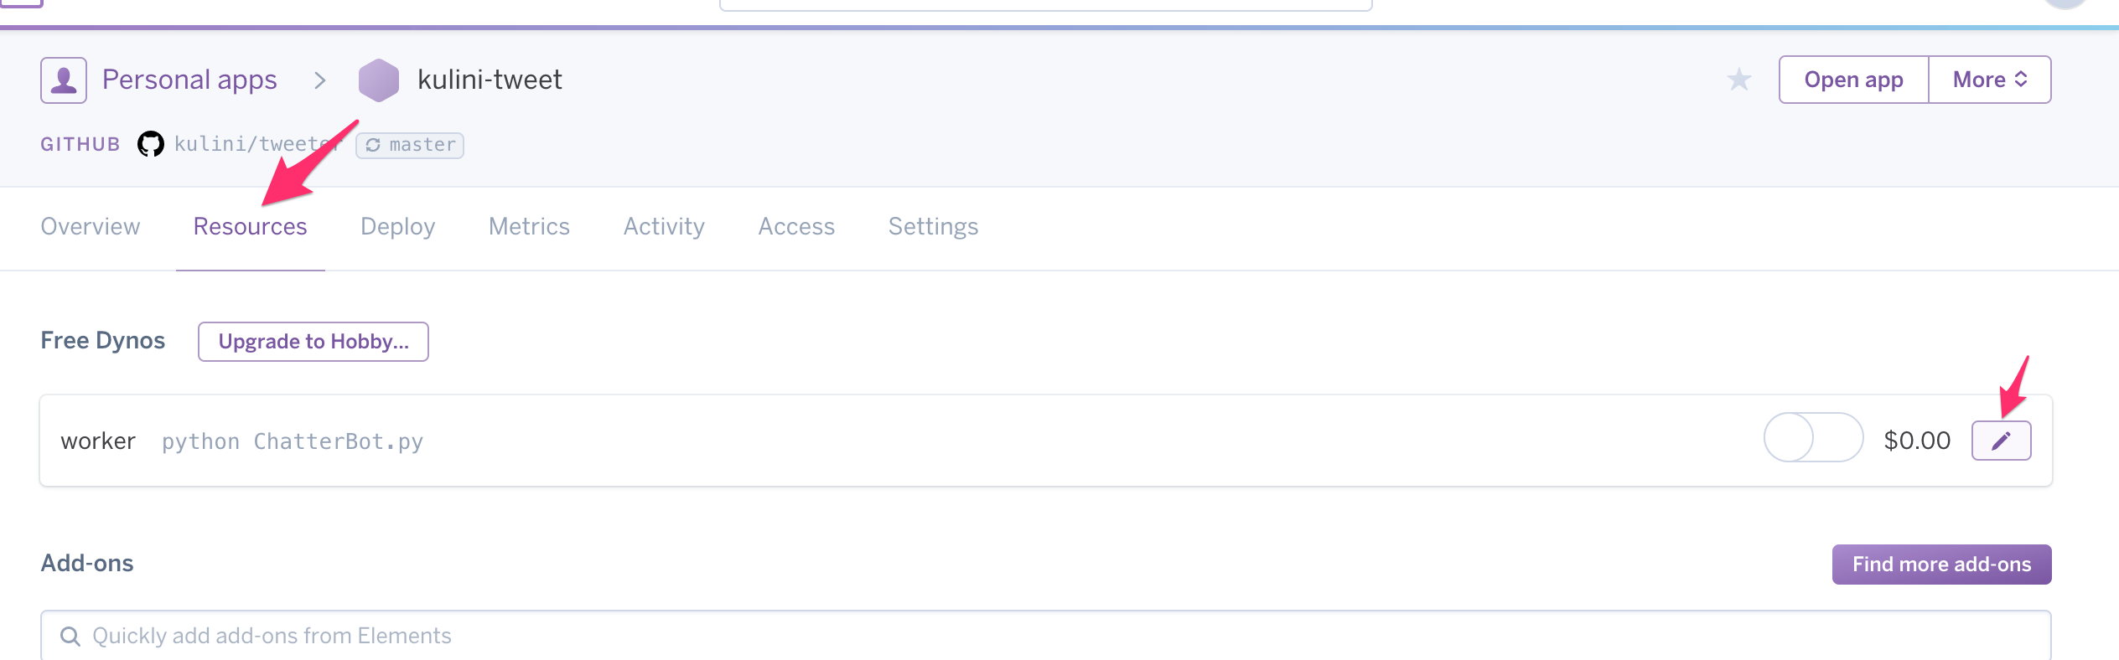

1. Slide the worker switch to the right, then click on Confirm.

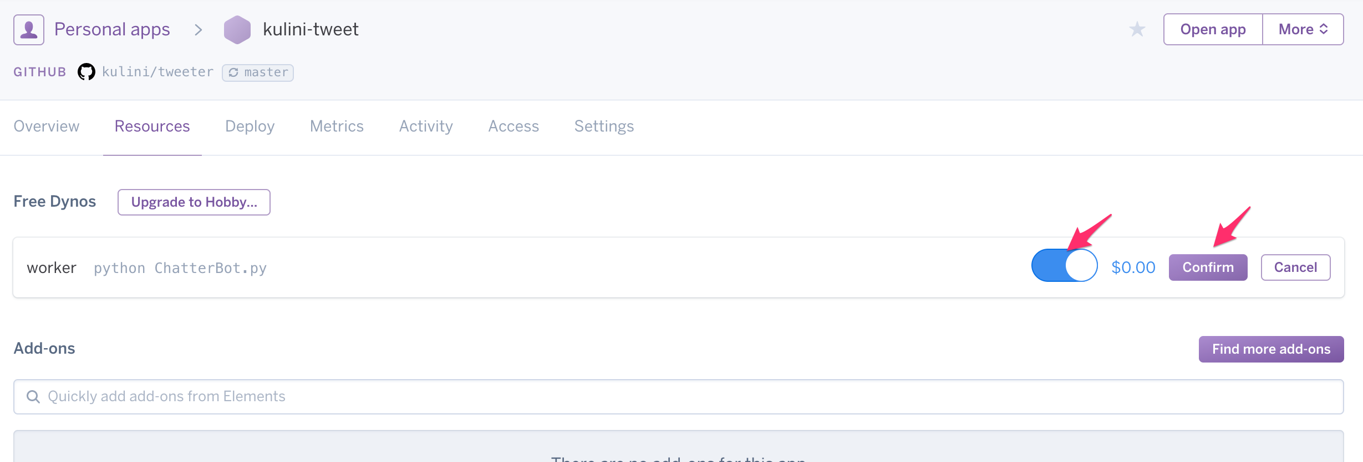

**How can my app work without my api key?**

First, I hope none of you post your API key on GitHub, someone can use your key and do weird stuff with it. Heroku’s solution is to create a secret environment that serves as your operating environment where you can get save your key as “config vars”.

Go to the Setting tab for your app.

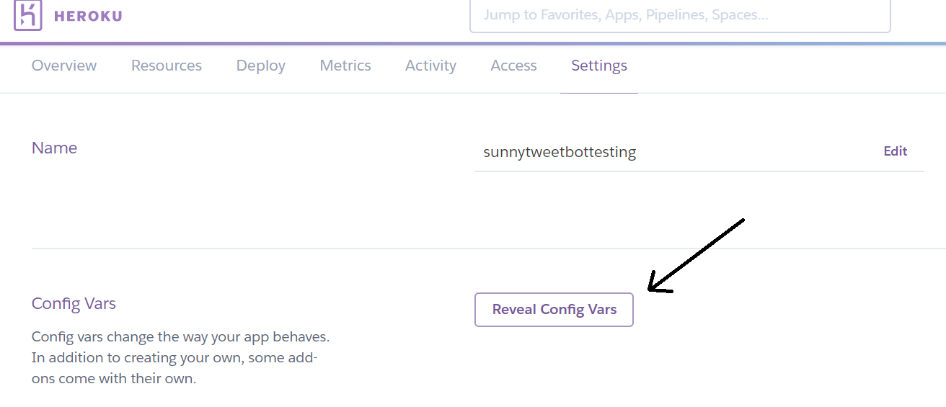

Click on Reveal Config vars , you can add your key.



Basically, your environment will have a dictionary called os.environ floating around.

So it kinda works like

os.environ = {Key : Value, …}

So how do I get a value from a dictionary?

os.environ[key] = value

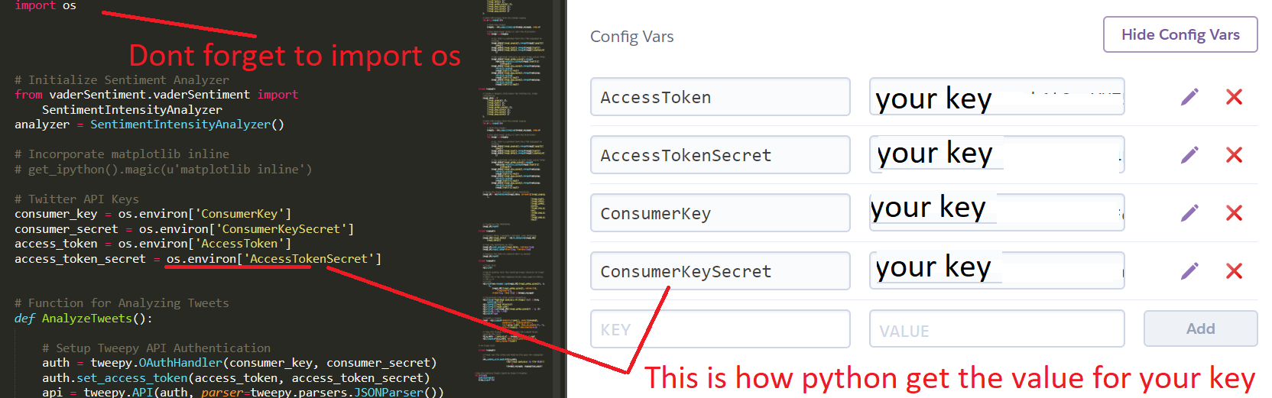This is how my set up is like between the environment and my code.

To check the status of your app deployment / config vars updates. Just go to the overview tab.

